3. Data Processing and Exploitation
1. Purpose
During the first week of the project, we established the Cyber Threat Intelligence foundation of the investigation, studied major DDoS attack types, and identified relevant threat sources and indicators.
During Week 2, we focused on collecting threat intelligence data related to DDoS and botnet infrastructure. The collected information included IP addresses, domains, URLs, hostnames, ASN information, network services, DNS-related information, and reputation data.
The purpose of Week 3 is to process the collected indicators, enrich them with additional threat intelligence information, and organize the resulting data in MISP.
2. Data Processing Workflow
The project follows the workflow below:
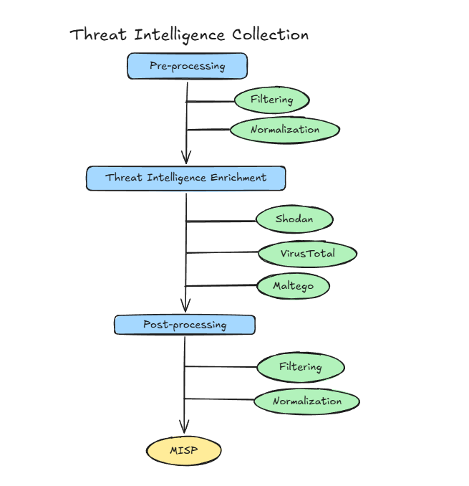
The workflow represents the overall processing pipeline used in the DDoS Threat Intelligence project. The current implementation covers collection, indicator selection, enrichment using VirusTotal and Shodan, and importing the processed indicators into MISP.
3. Collection of Threat Intelligence Data
The initial dataset contains publicly available indicators related to botnet infrastructure.
The collected data includes:
- domains;
- URLs;
- IP addresses;
- indicator type;
- source;
- observation date.
Some domain and URL indicators are classified as:
- botnet malware;
- botnet loader;
- botnet URL.
The initial indicators were collected from ThreatFox.
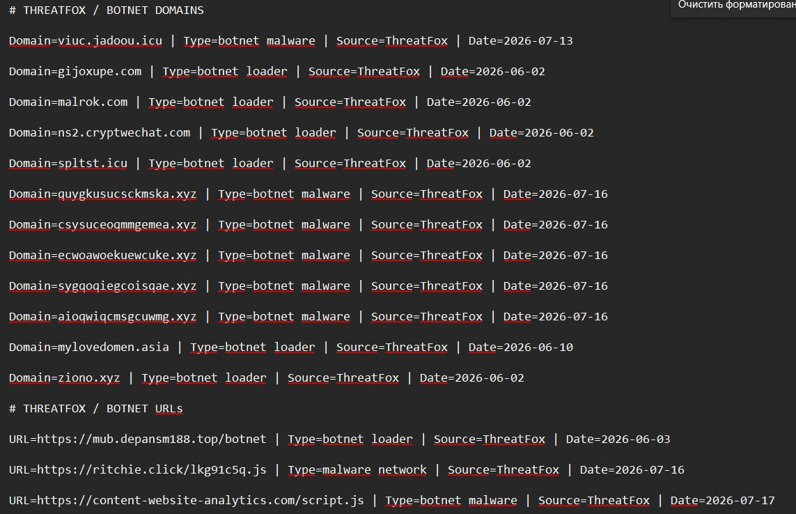
The screenshot shows the original domain and URL indicators collected from ThreatFox. Each record contains the indicator, its type, source, and date.
For example:
Domain = viuc.iadou.icu
Type = botnet malware
Source = ThreatFox
Date = 2026-07-13
These records represent the initial dataset used for further analysis.
4. Identification of Relevant IP Indicators
In addition to domains and URLs, IP indicators related to botnet infrastructure were collected.
Particular attention was given to indicators classified as:
ddos botnet c2
Examples include:
47.107.224.89
160.119.71.125
206.189.146.157
The dataset also contains indicators associated with Rondodox botnet infrastructure.
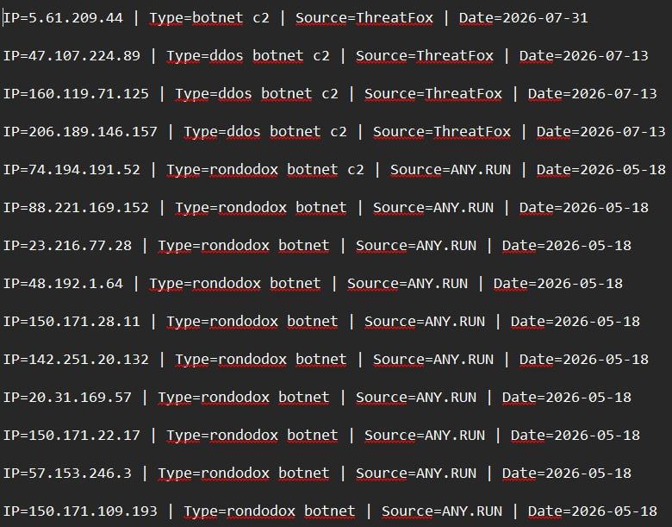
The initial IP records contain:
IP
Type
Source
Date
For example:
IP = 47.107.224.89
Type = ddos botnet c2
Source = ThreatFox
Date = 2026-07-13
This classification provides the initial threat context for the indicator. However, it does not by itself prove that the IP address directly participated in a DDoS attack. The indicator is therefore used as a starting point for further investigation.
5. Pre-processing
5.1. Filtering
Filtering is used to identify indicators that are relevant to the project and to reduce redundant or unrelated information.
The following factors are considered:
- indicator type;
- relevance to DDoS;
- source;
- observation date;
- available context;
- duplicate indicators.
The dataset includes both directly DDoS-related indicators and more general botnet infrastructure.
For example:
ddos botnet c2
has a direct connection to the investigated DDoS topic, while:
rondodox botnet
botnet loader
botnet malware
provide additional botnet-related context and should not automatically be interpreted as DDoS indicators.
This follows the course approach that data collection should be driven by a specific investigative purpose rather than by collecting data without a defined objective.
5.2. Normalization
Indicators obtained from different sources may use different formats and fields.
To make them easier to compare and process, the information is organized into a common structure:
Field | Description
Indicator | IP address, domain, URL
Type | Indicator type
Source | Original data source
Date | Observation date
Country | Geographic information
ASN | Autonomous System Number
AS Owner | ASN owner
Organization | Associated organization
Reputation | Reputation information
Ports | Observed ports

This structure allows information from different sources to be combined into a consistent dataset.
6. Threat Intelligence Enrichment
After the initial preparation, the collected indicators are enriched with additional threat intelligence information.
The purpose of enrichment is to transform a basic indicator into a more complete intelligence record.
The general process is:
Original Indicator
↓
ThreatFox Context
↓
VirusTotal Context
↓
Shodan Infrastructure Context
↓
Enriched Threat Intelligence Record

7. VirusTotal Enrichment
VirusTotal was used to obtain additional threat context for the collected IP indicators.
The resulting dataset contains fields such as:
- VT_Country;
- VT_ASN;
- VT_AS_Owner;
- VT_Malicious;
- VT_Suspicious;
- VT_Harmless;
- VT_Undetected.
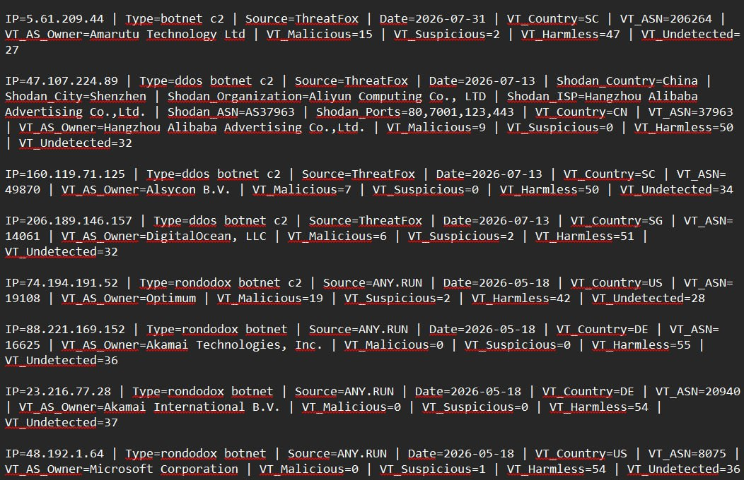
For example, for:
IP = 47.107.224.89
the VirusTotal information includes:
Country = CN
ASN = 37963
AS Owner = Hangzhou Alibaba Advertising Co., Ltd
Malicious = 9
Suspicious = 0
Harmless = 50
Undetected = 32
This information provides additional context about the network and the reputation of the indicator.
VirusTotal results are treated as additional evidence rather than an automatic final verdict. Different security engines may provide different results, so the information requires further interpretation and correlation. This approach is consistent with the Week 2 lecture, which describes VirusTotal as an enrichment source rather than a definitive verdict.
8. Shodan Enrichment
Shodan was used to obtain information about the Internet-facing infrastructure associated with the collected IP indicators.
The collected fields include:
- country;
- city;
- organization;
- ISP;
- ASN;
- open ports.
For example, for:
IP = 47.107.224.89
the collected information includes:
Country = China
City = Shenzhen
Organization = Aliyun Computing Co., LTD
ISP = Hangzhou Alibaba Advertising Co., Ltd
ASN = AS37963
Ports = 80, 7001, 123, 443
This information provides additional context about the infrastructure publicly visible on the investigated IP.
Shodan provides information about observed Internet-facing services and infrastructure; it does not automatically prove that an IP address is a source of DDoS activity.

9. Combining Information from Multiple Sources
After enrichment, information from different sources can be combined to create a more complete profile of the same indicator.
For example, the IP address 47.107.224.89 was originally identified by ThreatFox as a ddos botnet c2 indicator. Additional information was then obtained from VirusTotal, including its country, ASN, AS owner, and detection results. Shodan provided further infrastructure information, including country, city, organization, ISP, ASN, and open ports.
Combining these results gives us a broader context for the investigated IP address and makes it more useful for further threat analysis.
The purpose of this stage is to combine different views of the same indicator and preserve the context provided by each source, rather than relying on information from a single source.
10. MISP
After processing and enrichment, the indicators were imported into MISP for structured storage and further threat intelligence analysis.
MISP is an open-source threat intelligence platform used for gathering, storing, sharing, and correlating threat information.
In the project, the imported IP indicators are represented as Network activity attributes with the type ip-src.
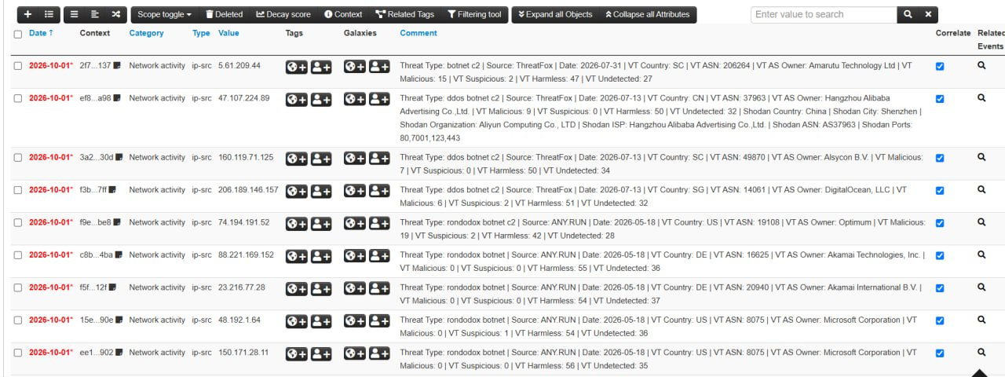
The MISP view contains multiple imported IP indicators and shows information such as:
- Date;
- Category;
- Type;
- Value;
- Tags;
- Galaxies;
- Comments;
- Correlation settings.
The comments preserve context collected during the previous stages, including:
- threat type;
- source;
- observation date;
- VirusTotal information;
- Shodan information.
For example, the entry for 47.107.224.89 contains the original ddos botnet c2 classification from ThreatFox together with VirusTotal and Shodan enrichment data.
This allows the final MISP dataset to contain structured and contextualized indicators rather than a simple list of IP addresses.
11. Current Result
The current Week 3 workflow can be summarized as:
ThreatFox
↓
Raw Indicators
↓
Relevant IP Indicators
↓
VirusTotal + Shodan Enrichment
↓
Enriched Threat Intelligence
↓
MISP
The resulting records contain additional information such as:
- ASN;
- AS owner;
- country;
- organization;
- ISP;
- open ports;
- reputation;
- detection information.
This additional context makes the indicators more useful for further analysis of DDoS and botnet-related infrastructure.

12. Conclusion
During Week 3, the project moved from basic threat intelligence collection to data processing and enrichment.
First, domains, URLs, and IP addresses related to botnet infrastructure were collected from ThreatFox. Relevant IP indicators, including indicators classified as ddos botnet c2, were then identified for further analysis.
The selected IP indicators were enriched with additional information from VirusTotal and Shodan. The resulting context included ASN, AS owner, geographic information, organization, ISP, open ports, and reputation or detection data.
Finally, the enriched indicators were imported into MISP and stored as structured network activity attributes together with their additional context.
Therefore, the main Week 3 workflow is:
Collection - > Pre-processing - >Threat Intelligence Enrichment - >MISP
This stage provides a structured and contextualized dataset that can be used for further analysis of DDoS-related infrastructure and subsequent threat-hunting activities.

